**1. Risk Identification**

Floods can cause widespread devastation, and thereby present a major environmental health risk. Between 1994 and 2013, floods were responsible for the majority (43%) of natural disasters; affecting nearly 2.5 billion people worldwide. [1] Among a number of adverse socioeconomic impacts, floods have devastating consequences on human health causing thousands to die every year. [2] They can impact human health directly by causing deaths or injuries, or indirectly by creating favorable conditions for the spread of diseases, and damaging critical public health infrastructure.

**Case in Point:**

In early January of 2015, devastating rains hit Malawi resulting in massive floods across the country, affecting an estimated 638,000 people. A state of disaster was issued on 13 January that requested USD 81 million to address the immediate needs of the impacted population across 15 districts. 79 deaths were associated with the floods and an outbreak of cholera in February resulted in 693 reported cases and 11 deaths (Department of Disaster Management Affairs of Malawi and United Nations Office of the Resident Coordinator 2015) (ReliefWeb n.d.).

**Health impacts**

A variety of direct and indirect health impacts and risks can arise from flooding. While a large number of health implications during floods result from physical injury, vector and waterborne disease outbreaks often arise a few days into, or after a flood event. Outbreaks of diarrheal diseases are also observed during floods, such as in the severe flood events in Bangladesh in 1998 and 2004.**Error! Bookmark not defined.** After floods, outbreaks of loeptospirosis, typhoid and hepatitis E have been recorded, particularly in areas with poor hygiene and displaced populations. Risk of infections such as conjunctivitis and dermatitis are also heightened after floods, though are not prone to cause epidemics.8 Adverse health outcomes of floods include:

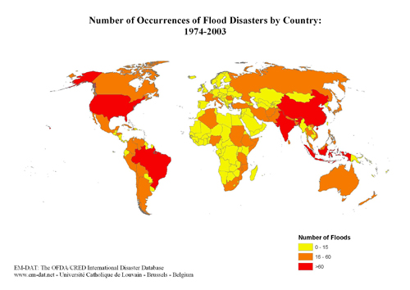

* Drowning or physical trauma (e.g. injury, trauma, hypothermia, snake bites)
* Diarrheal diseases, such as cholera and typhoid8
* leptospirosis
* hepatitis E
* malaria
* other skin infections
* psychological distress
* Damage to infrastructure and disruption to the food supply and health care systems limits people’s access to healthcare and impacts food security [3][4]8

Figure 1. Number of Occurrences of Flood Disasters by Country: 1974-2003.

**Mechanisms**

Floods can manifest in different ways (such as flash floods, coastal floods, riverine floods etc.), which can bring varying risks to human health. While flash floods are more likely to cause immediate injury, rises in water level will most likely impact sewage systems. When flooding causes sewage and drinking water to mix, this can result in waterborne pathogens entering the water supply. Stagnant pools of water provide needed conditions for bacterial growth and can offer breeding grounds for disease carrying vectors such as mosquitos8 while storm surges and sea level rise can cause the contamination of groundwater through saltwater intrusion, resulting in outbreaks of waterborne diseases.**Error! Bookmark not defined.**

**Where do floods contribute to health problems?**

Flooding affects many regions across the globe, yet populations in some areas are more exposed to floods and ensuing health consequences than in others. India, Bangladesh, Pakistan, and China have experienced a notable number of deaths, totaling in the thousands, associated with flooding.1 Floods have resulted in significant disease outbreaks around the world, including diarrhea in Mozambique in 20008; cholera in West Bengal in 19988; leptospirosis in Brazil in 1983, 1988, and 19968 as well as Lao’s People’s Democratic Republic in 2005**Error! Bookmark not defined.**[5]; malaria in the Dominican Republic in 20048**Error! Bookmark not defined.**; and West Nile Fever in the Czech Republic in 1997.8

**Who is at risk?**

Floods are the most common disaster in the world and affect people worldwide. Between 1994 and 2013, Asia and Africa experienced more floods than other continents. Meanwhile, the populations living in flood prone river basins and on coastlines have increased by 114% and 192%, respectively.**Error! Bookmark not defined.** Some observations on mortality trends indicate that children and the elderly are at a heightened risk for flood related deaths.[6] Additionally, some studies have revealed that in developed countries males are at increased risk to die during floods, while in less developed countries the mortality risk transfers to women.6 Furthermore, while populations living in flood prone areas are most at risk to suffer the health consequences, displaced populations and those without access to adequate health care and clean drinking water also show increased vulnerability.

**Diseases associated with floods**

* [Water-borne diseases](http://www.who.int/hac/techguidance/ems/flood_cds/en/)[7][8][9]
  + [Cholera](http://www.who.int/topics/cholera/en/)
  + [Diarrhea](http://www.who.int/topics/diarrhoea/en/)
  + [Typhoid fever](http://www.who.int/topics/typhoid_fever/en/)
  + [Leptospirosis](http://www.who.int/topics/leptospirosis/en/)
  + [Hepatitis A](http://www.who.int/mediacentre/factsheets/fs328/en/)
* [Vector-borne diseases](http://www.who.int/hac/techguidance/ems/flood_cds/en/)
  + [Malaria](http://www.who.int/topics/malaria/en/)
  + [Dengue and dengue hemorrhagic fever](http://www.who.int/csr/disease/dengue/en/)
  + [Yellow fever](http://www.who.int/mediacentre/factsheets/fs100/en/)
  + [West Nile Virus](http://www.who.int/mediacentre/factsheets/fs354/en/)

**2. Flood Monitoring and Forecasting Tools useful for Health Risk Assessment**

|  |  |  |  |  |  |
| --- | --- | --- | --- | --- | --- |
| Risk Monitoring Tools | | Global | Regional | National | Health |
| [African Flood and Drought Monitor](http://stream.princeton.edu/AWCM/WEBPAGE/interface.php?locale=en) | Interactive drought and flood monitoring and forecasting tool, utilizing multiple datasets (e.g. precipitation, maximum temperature, streamflow, drought index), for Africa over different temporal scales. |  | ● |  |  |
| [Global Flood and Landslide Monitoring - NASA](http://pmm.nasa.gov/trmm/flood-and-landslide-monitoring) | Near-real time information on heavy rainfall and flood potential maps of the global scale. | ● |  |  |  |
| [Global Flood Monitoring System (GFMS)](http://flood.umd.edu/) | Flood detection and intensity estimates for most of the globe (50°N to 50°S). | ● |  |  |  |
| [Dartmouth Flood Observatory (DFO)](http://floodobservatory.colorado.edu/index.html) | DFO has near-real time information on current floods around the world as well as global flood data from 1985 to the present. | ● |  |  |  |
| [Vibrio Map Viewer by E3 Geoportal, European Environmental and Epidemiology Network](https://e3geoportal.ecdc.europa.eu/SitePages/Vibrio%20Map%20Viewer.aspx) | Near-real time model that provides global remotely sensed information on environmental variables that are suitable forcholera bacteria, *Vibrio* spp, which informs areas of potential human exposure. Additionally, the portal includes a 5-day forecast. |  | ● |  | ● |
| [Global Flood Detection System – Version 2](http://www.gdacs.org/flooddetection/overview.aspx) | Near-real time satellite observations of river floods around the world. | ● |  |  |  |
| Risk Forecasting Tools | | **Global** | **Regional** | **National** | **Health** |
| [National Oceanic and Atmospheric Administration – Automated Flood Warning System](http://water.weather.gov/afws/) | Automated flood alerts for the United States. Also includes precipitation and [river observations](http://water.weather.gov/ahps/index.php) and [river forecasts](http://water.weather.gov/ahps/forecasts.php). |  |  | ● |  |
| [UK Met Office – Flood Warnings](http://www.metoffice.gov.uk/public/weather/flood-warnings/#?tab=floodWarnings) | Issues flood warnings and alerts with updates every 15 minutes. |  |  | ● |  |
| [European Flood Awareness System](https://www.efas.eu/) | Monitors floods and issues alerts up to 10 days in advance of flooding to partners. |  | ● |  |  |
| [Meteoalarm](http://www.meteoalarm.eu/?lang=en_UK) | Provides flood warnings and alerts for Europe. Information is displayed on an interactive map with available reports and warnings that can be downloaded for each country that have high alerts. |  | ● |  |  |
| [IRI Data Library Maproom – International Federation of Red Cross and Red Crescent Societies: Forecasts in Context](http://iridl.ldeo.columbia.edu/maproom/IFRC/) | Provides historical maps and forecasts regarding heavy precipitation. Contains 6 day and 3 month forecasts as well as recent climate trends, past conditions, and vulnerability indicators to help decision-makers take action. | ● |  |  |  |
| [Global Flood Monitoring System (GFMS)](http://flood.umd.edu/) | Short-term (4 to 5 day outlooks) flood forecasts for most of the globe (50°N to 50°S) using satellite data. | ● |  |  |  |
| [Central America Flash Flood Guidance System](http://www.hrc-lab.org/right_nav_widgets/realtime_caffg/index.php) | Flash flood guidance for Central America pertaining to flash flood threats. Products are updated every 6 hours. |  | ● |  |  |
| [3-Day Flood Risk: UK](http://apps.environment-agency.gov.uk/flood/3days/125305.aspx) | Provides forecasts for 3 days in advance that are updated daily. Issues summaries and maps for counties in England and Wales. |  |  | ● |  |
| [Global Flood Awareness System](http://www.globalfloods.eu/) | Provides daily flood forecasts that incorporate weather forecasts with a hydrological model to produce global flood forecasts. | ● |  |  |  |
| [Mekong River Commission](http://ffw.mrcmekong.org/overview.htm) | Flood forecasting and monitoring system for the Mekong River Basin. Provides flash flood warning products, water level data, rainfall data, maps of maximum flood extent, and historical data and reports for the basin and sub-basin level. |  | ● |  |  |
| [Bangladesh Flood Forecasting and Warning Centre](http://www.ffwc.gov.bd/) | Provides flood forecasting and warnings for Bangladesh. These are available in 5-day and medium range (1-10 day) formats. Additionally, offers hydrograph forecasts for individual rivers and streams as well as water level data and rainfall data. |  |  | ● |  |
| [Pacific Disaster Center](http://www.pdc.org/resources/natural-hazards/floods/) | Provides flood and tsunami warnings and alerts for the countries in the Pacific. |  | ● |  |  |
| [EFAS – The European Flood Awareness System](http://emergency.copernicus.eu/mapping/ems/efas-european-flood-awareness-system) | Delivers Pan-European flood probability maps for up to 10 days in advance and detailed flood forecasts from national weather stations. |  | ● | ● |  |

## 3. Resources for Health Risk Management during Floods

|  |  |  |  |  |  |
| --- | --- | --- | --- | --- | --- |
| Risk Management and Communication Tools | | Global | Regional | National | Health |
| Guidance Documents |  |  |  |  |  |
| [University Corporation for Atmospheric Research’s (UCAR) and NOAA Flash Flood Early Warning System Reference Guide 2010](http://www.meted.ucar.edu/communities/hazwarnsys/ffewsrg/FF_EWS.pdf) | Guidance document for the development and maintenance of flash flood warning systems. | ● |  |  |  |
| [WHO/WMO Atlas of Health and Climate](http://www.who.int/globalchange/publications/atlas/en/) | Provides scientific information on the connection of weather and climate and health challenges. | ● |  |  | ● |
| [WHO – Floods in the WHO European Region: Health Effects and Their Prevention](http://www.euro.who.int/__data/assets/pdf_file/0020/189020/e96853.pdf?ua=1) | Provides information to help WHO European member states to understand the health risks from flooding and how to develop public health responses for flood prevention. |  | ● |  | ● |
| [WMO Guidelines on Early Warning Systems and Application of Nowcasting and Warning Operations](https://www.wmo.int/pages/prog/amp/pwsp/documents/PWS-21.pdf) | Guidance on the development of early warning systems and the application of warning systems and nowcasting operations. | ● |  |  |  |
| [Black Sea and Middle East Flash Flood Guidance System User Guide](http://www.wmo.int/pages/prog/hwrp/flood/ffgs/documents/BSMEFFG_UserGuide-opt.pdf) | Provides operational insight into the Black Sea and Middle East flash flood guidance systems. |  | ● |  |  |
| [WHO/WEDC Technical notes on WASH Emergencies](http://www.who.int/water_sanitation_health/publications/2011/technotes/en/) | Provide practical recommendations on responding to immediate and medium-term water, sanitation, and hygiene needs of populations impacted by emergencies. | ● |  |  | ● |
| [WMO Flash Flood Guidance Systems](http://www.wmo.int/pages/prog/hwrp/documents/FFI/Flash_Flood_Guidance_Systems_Background_Information.pdf) | Document provides background on Flash Flood Guidance Systems and describes their scientific basis, development, and recommended resources. | ● |  |  |  |
| [Flash Flood Warning System Reference Guide](https://www.meted.ucar.edu/training_module.php?id=958#.VrT_m1MrLdQ) | Guide describes proven and effective methods for the development and implementation of flash flood early warning systems. Provides case studies and other examples of early warning systems from around the world. | ● |  |  |  |
| [Flooding – Frequently Asked Health Questions](https://www.gov.uk/government/uploads/system/uploads/attachment_data/file/348925/Flooding_questions_and_answers_February_2014.pdf) | Public Health England provides an overview of commonly asked questions regarding the threats to health from floods. Offers tips and guidance on preparation and safety. |  |  | ● | ● |
| [Floods, health and climate change: a strategic review](http://www.tyndall.ac.uk/sites/default/files/wp63.pdf) | Provides a review on global health impacts from flooding, identifies challenges for intervention, and assesses the implications of climate change on future health impacts. | ● |  |  | ● |
| [Health impacts of floods in Europe: Data gaps and information needs from a spatial perspective](http://www.cred.be/sites/default/files/Health_impacts_of_floods_in_Europe.pdf) | Report outlines the health impacts of floods in European countries using both statistical and spatial data. |  | ● |  | ● |
| [Cities and Flooding: A Guide to Integrated Urban Flood Risk Management for the 21st Century](https://openknowledge.worldbank.org/handle/10986/2241) | Guidance document for policy-makers, government officials, stakeholders for information on urban flood risk management. | ● |  |  |  |
| Web Resources |  |  |  |  |  |
| [European Commission – Flooding in Europe: Health Risks](http://ec.europa.eu/health/climate_change/extreme_weather/flooding/index_en.htm) | Provides information on the health risks from flooding as well as links out to pertinent resources and documents. |  | ● |  | ● |
| [WHO Flooding and Communicable Diseases Fact Sheet](http://www.who.int/hac/techguidance/ems/flood_cds/en/) | Provides information on diseases associated with floods. | ● |  |  | ● |
| [Centers for Disease Control and Prevention (CDC) - Floods](http://www.emergency.cdc.gov/disasters/floods/) | Site provides information about the health impact from floods and how to prepare for them. | ● |  | ● | ● |
| [National Institute of Environmental Health Sciences](http://www.niehs.nih.gov/research/programs/geh/climatechange/health_impacts/waterborne_diseases/index.cfm) | Provides information on the health impacts associated with floods along with mitigation and adaptation options and research needs. | ● |  |  |  |
| [Disaster Information Management Research Center - Floods](https://sis.nlm.nih.gov/dimrc/floods.html#a1) | Contains information, resources, documents, and guidance tools for the preparation and management of the health risks posed by flooding. | ● |  | ● | ● |
| [Environmental Protection Agency - Flooding](http://www.epa.gov/natural-disasters/flooding) | Information pertaining to health safety during and after a flood. |  |  | ● | ● |
| [Flood List](http://floodlist.com/) | Provides near-real time information on major flood events from around the world from news reports. Includes articles, reports, and resources on the impacts of floods on humanity. | ● | ● | ● | ● |
| [Public Health England](https://www.gov.uk/government/collections/flooding-health-guidance-and-advice) | Provides guidance documents on health risks to floods and how to address those risks. |  |  | ● | ● |
| [Natural Resources Defense Council – Flooding: Devastating Floods and Heavy Rains](http://www.nrdc.org/health/climate/floods.asp) | Overview of the health impacts of floods in the United States. Provides links to different state’s plans to address the risk of flooding. |  |  | ● | ● |
| [Disaster Information Management Research Center](https://sis.nlm.nih.gov/dimrc/floods.html#a0) | Contains extensive information and links to resources on the health impacts from floods, preparedness and response information, cleanup and recovery, and other resources geared to specific populations. | ● |  | ● | ● |
| Key Relevant Programs and Partners |  |  |  |  |  |
| [World Health Organization](http://www.who.int/hac/techguidance/preparedness/en/) | Emergency and Disaster Risk Management for Health program provides support to improve health outcomes for countries dealing with disasters and emergencies. | ● |  |  | ● |
| [World Meteorological Organization](https://www.wmo.int/pages/themes/climate/applications_health.php) | Supports the health sector with weather and climate science tools, services, and resources. | ● |  |  |  |
| [Associated Programme on Flood Management](http://www.apfm.info/) | Supports an integrated approach to flood management in numerous countries. Works in partnership with the Global Water Partnership and WMO. | ● |  |  |  |
| [CDC Emergency Preparedness and Response](http://emergency.cdc.gov/disasters/floods/index.asp) | Provides health information in relation to floods and guidance on how to prepare, respond, and stay safe during flood events. |  |  | ● | ● |
| [National Institutes of Health](http://www.niehs.nih.gov/research/programs/geh/climatechange/health_impacts/index.cfm) | National Institute for Environmental Health Services program studies the environmental impacts on health in order to promote healthier lives. | ● |  |  | ● |
| [World Bank](http://www.worldbank.org/) | Supports and implements programs and projects in the health and water sectors. | ● |  |  |  |

**Screenshots for different risk monitoring/forecasting products**

[African Flood and Drought Monitor](http://stream.princeton.edu/AWCM/WEBPAGE/interface.php?locale=en)

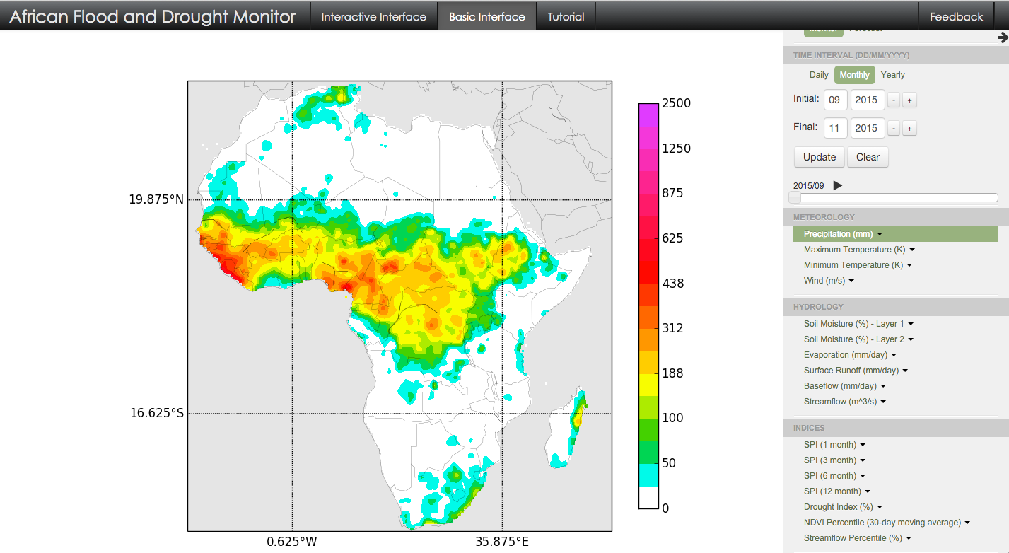

[Global Flood and Landslide Monitoring from NASA](http://pmm.nasa.gov/trmm/flood-and-landslide-monitoring)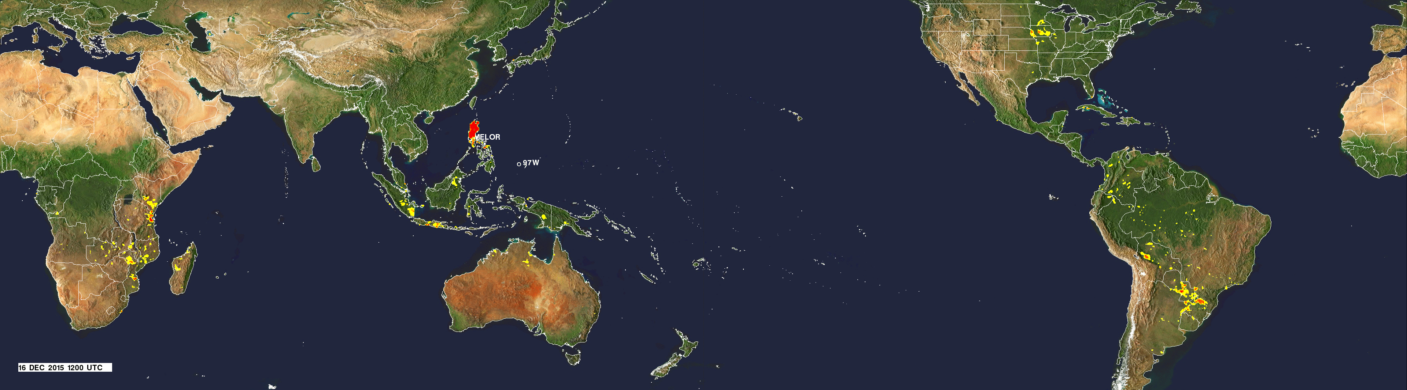

[Vibrio Map Viewer by E3 Geoportal, European Environmental and Epidemiology Network](https://e3geoportal.ecdc.europa.eu/SitePages/Vibrio%20Map%20Viewer.aspx)

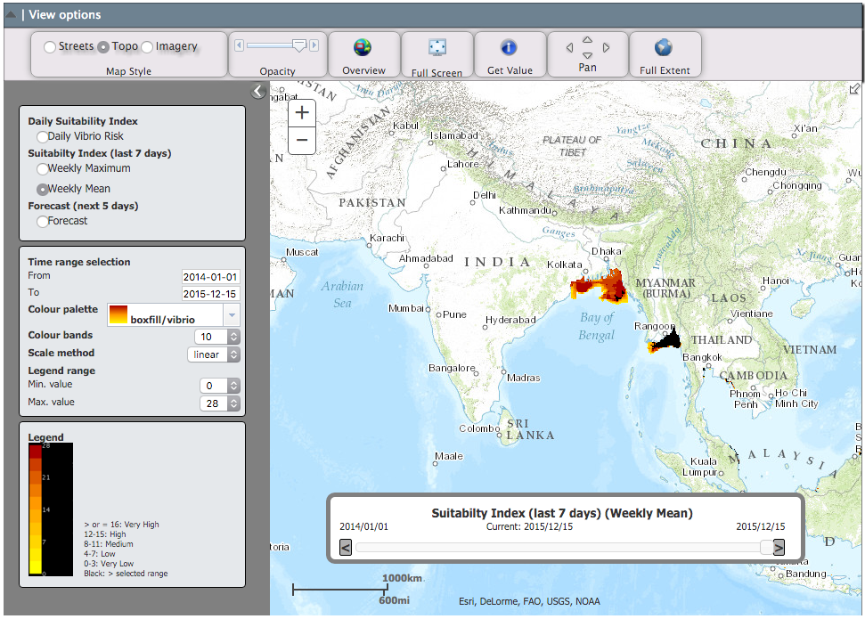

[Meteoalarm](http://www.meteoalarm.eu/?lang=en_UK)

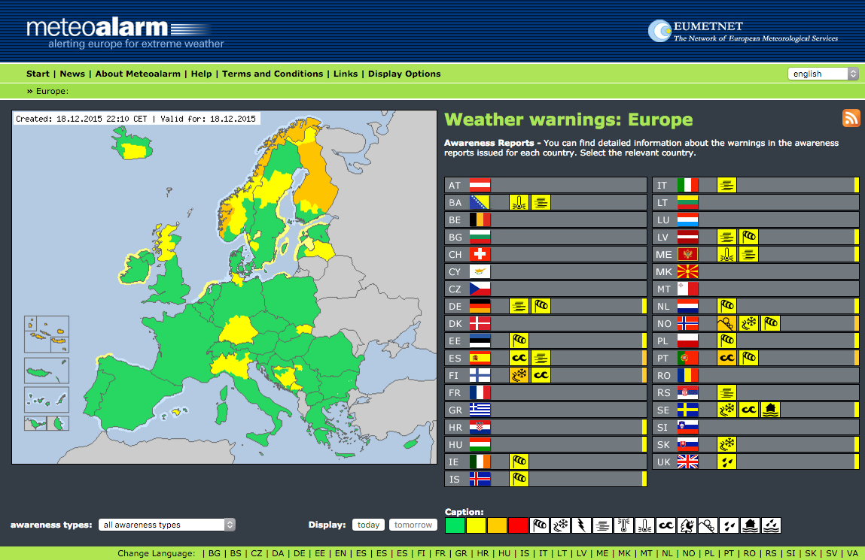

[IRI Data Library Maproom – International Federation of Red Cross and Red Crescent Societies: Forecasts in Context](http://iridl.ldeo.columbia.edu/maproom/IFRC/)

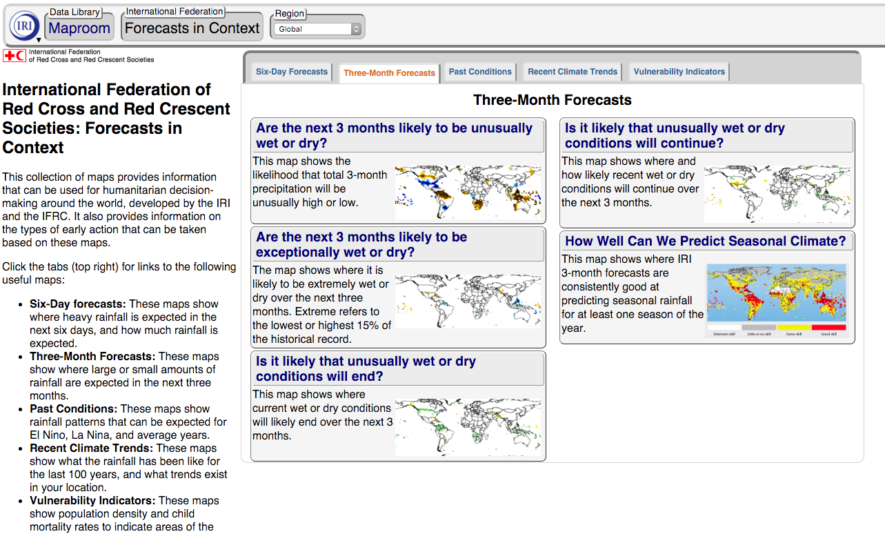

# Bibliography

Centers for Disease Control and Prevention (CDC). *Flood Waters or Standing Waters.* January 23, 2016. http://www.cdc.gov/healthywater/emergency/extreme-weather/floods-standingwater.html (accessed February 04, 2016).

Centre for Research on the Epidemiology of Disasters (CRED). "The Cost of Natural Disasters: A global perspective." 2015.

Centre for Research on the Epidemiologyof Disasters (CRED). *Disaster Types.* http://www.emdat.be/disaster-types (accessed December 15, 2015).

Department of Disaster Management Affairs of Malawi and United Nations Office of the Resident Coordinator. "Malawi: Floods." Situation Report, 2015.

Intergovernmental Panel on Climate Change (IPCC). *Climate Change 2014: Synthesis Report. Contribution of Working Groups I, II and III to the Fifth Assessment Report of the Intergovernmental Panel on Climate Change.* Edited by R.K. Pachauri and L.A. Meyer Core Writing Team. Geneva: IPCC, 2014.

Jeremy J. Hess, Julia Z. McDowell, George Luber. "Integrating Climate Change Adaptation into Public Health Practice: Using Adaptive Management to Increase Adaptive Capacity and Build Resilience." *Environmental Health Perspectives* 120 (2012): 171-179.

Katarzyna Bolsewicz Alderman. "Floods and human health: A systematic review." *Environmnet International* (Elsevier Ltd.) 47 (2012): 37-47.

Leo Kawaguchi, Bounthanom Sengkeopraseuth, Reiko Tsuyuoka, Nobuo Koizumi, Hidechika Akashi, Phengta Vongphrachanh, Haruo Watanabe,Atsuko Aoyama. "Seroprevalence of Leptospirosis and Risk Factor Analysis in Flood-prone Rural Areas in Lao PDR." *The American Journal of Tropical Medicine and Hygiene* 78, no. 6 (2008): 957-961.

ReliefWeb. *Disasters: Southern Africa: Floods - Jan 2015.* http://reliefweb.int/disaster/fl-2015-000006-mwi (accessed February 09, 2016).

Republic of Turkey Ministry of Forestry and Water Affairs and Turkish Meteorological Service. *Black Sea and Middle East Flash Flood Guidance System User Guide.* User Guide, TSMS Printing House, 2015.

Shannon Doocy, Amy Daniels, Sarah Murray, Thomas D. Kirsch. "The Human Impact of Floods: a Historical Review of Events 1980-2009 and Systematic Literature Review." *PLOS Currents Disasters*, April 2013.

Watts, Nick. "Health and climate change: policy responses to protect public health." *The Lancet Commissions* 386 (2015): 1861-1914.

World Bank. *Turn down the Heat: Climate extremes, Regional Impacts, and the Case for Resilience.* Washington, D.C.: World Bank, 2013.

World Health Organization (WHO) and World Meteorological Organization (WMO). *Atlas of Health and Climate.* Geneva: WHO Press, 2012.

World Health Organization. *Flooding and communicable diseases fact sheet.* 2016. http://www.who.int/hac/techguidance/ems/flood_cds/en/ (accessed February 04, 2016).

—. *Water-related diseases.* 2016. http://www.who.int/water_sanitation_health/diseases/diarrhoea/en/ (accessed February 04, 2016).

1. (Centre for Research on the Epidemiology of Disasters (CRED) 2015)
2. (Republic of Turkey Ministry of Forestry and Water Affairs and Turkish Meteorological Service 2015)
3. (World Health Organization (WHO) and World Meteorological Organization (WMO) 2012)
4. (World Bank 2013)
5. (Leo Kawaguchi 2008)
6. (Shannon Doocy 2013)
7. (Centers for Disease Control and Prevention (CDC) 2016)
8. (World Health Organization 2016)
9. (World Health Organization 2016)